21st September 2018

**YOKOHAMA on the challenging track of Vallelunga**

The Italian Sport Prototype Championship continued at the last weekend the Roman circuit of Vallelunga, one of the most difficult tracks on Italian territory. The penultimate round of the Italian Sport Prototype Championship offered Two 25-minute heats plus one lap, with inverted grid in the second, which excited the passionate crowds of racing fans in attendance.

YOKOHAMA Italia supplied the slick ADVAN A005 tyres to the Wolf Racing Cars' Wolf GB08 Thunder. Pole man Matteo Pollini achieved race 1 victory and his second seasonal success came after a thrilling tussle.

Meanwhile race 2 was won by Andrea Gagliardini making this the seventh different winner in the ten races held so far. Worthy of note was also the performance of Lorenzo Pegoraro who, in race 2, started last and finished third, taking the lead in the general classification.

"The two races at the Vallelunga circuit have been very demanding." – stated Giuseppe Pezzaioli, Head of Motorsport at YOKOHAMA Italia - "Our slick models have guaranteed high and constant performances throughout and have very successfully withstood the high level of stress due to the high-speed corners of this circuit. Adding he was very satisfied with the 2018 season whislt stating - “I look forward to the last race scheduled in October to find out who will win the Championship. Everything is still open ".

The next and final stage of the Italian Sport Prototype Championship will be at Mugello at the end of October: on 26th, 27th and 28th.

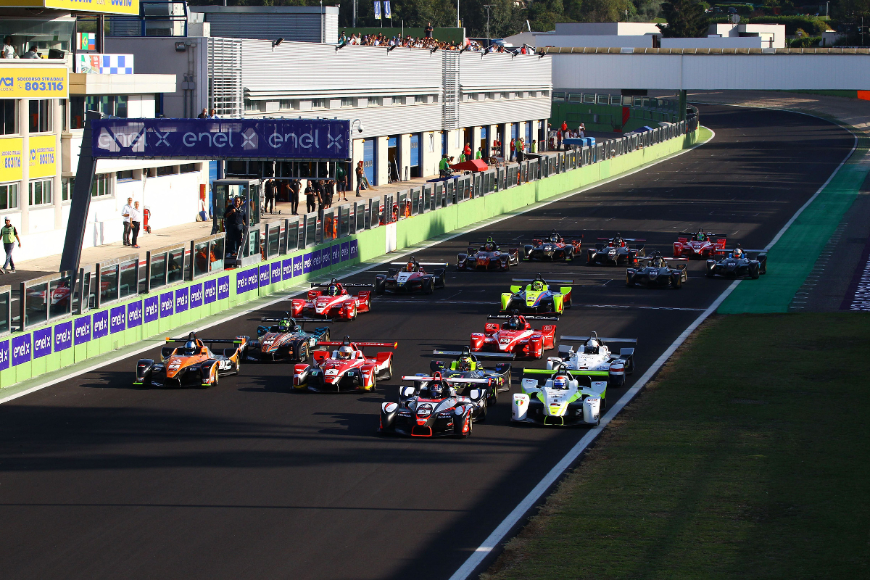

*Vallelunga1*

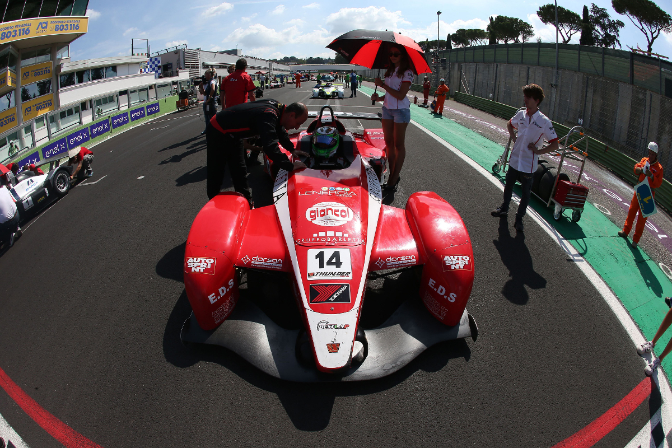

*Vallelunga2*